**Challenge**

Challenge by: Carl Allchin

This week we are looking at the different Brands of bikes available in our stores. We need to understand what are the most popular sellers and do the customers of the different brands have the same experience to other customers.

We are creating simple summaries this week to get a quick, tabular view of the answers. If you want to visualise the data to highlight those trends even more clearly, go for it!

**Input**

[One csv file of bike sales](https://drive.google.com/file/d/1B8iPx1W8wTq8-RcwRWWPzWLDrCeR-o9p/view?usp=sharing).

[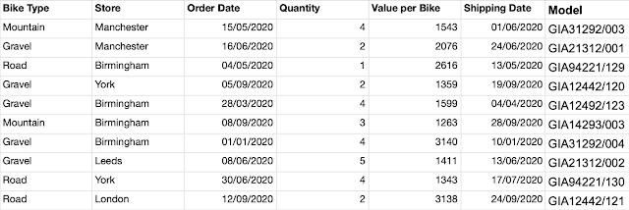](https://1.bp.blogspot.com/-z_heCV23gPQ/X_rk1Pa7a8I/AAAAAAAACGM/v4DDRd218DcDw71jZPbyVVGgxkee-wSsQCLcBGAsYHQ/s2374/Screenshot%2B2021-01-10%2Bat%2B11.27.51.png)

**Requirements**

* [Input the data](https://drive.google.com/file/d/1B8iPx1W8wTq8-RcwRWWPzWLDrCeR-o9p/view?usp=sharing) ([*help*](https://preppindata.blogspot.com/2019/12/how-to-connect-to-data-in-files.html))
* Clean up the Model field to leave only the letters to represent the Brand of the bike ([*help*](https://preppindata.blogspot.com/2020/03/how-to-deal-with-unwanted-characters.html))
* Workout the Order Value using Value per Bike and Quantity.
* Aggregate Value per Bike, Order Value and Quantity by Brand and Bike Type to form: ([*help*](https://preppindata.blogspot.com/2019/07/how-to-aggregate-in-prep-builder.html))
  + Quantity Sold
  + Order Value
  + Average Value Sold per Brand, Type
* Calculate Days to ship by measuring the difference between when an order was placed and when it was shipped as 'Days to Ship' ([*help*](https://preppindata.blogspot.com/2020/01/how-tomake-calculations.html))
* Aggregate Order Value, Quantity and Days to Ship by Brand and Store to form:
  + Total Quantity Sold
  + Total Order Value
  + Average Days to Ship
* Round any averaged values to one decimal place to make the values easier to read
* [Output both data sets](https://drive.google.com/drive/folders/17_FYWuDo_46jkO8sAsSu9blOKMxH5vYo?usp=sharing) ([*help*](https://preppindata.blogspot.com/2020/01/how-to-choose-output.html))

**Output**

[Two files](https://drive.google.com/drive/folders/17_FYWuDo_46jkO8sAsSu9blOKMxH5vYo?usp=sharing):

1. Sales by Brand and Type

[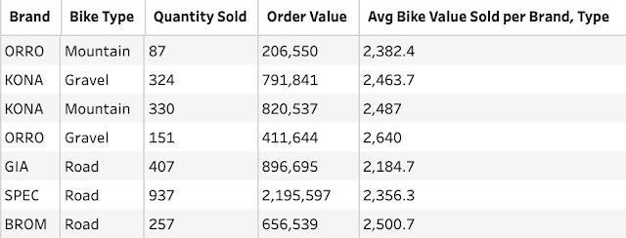](https://1.bp.blogspot.com/-pIoOV-rm3JM/X_8FXjz9FbI/AAAAAAAACGs/mWo2N0mn1vwHqnH-_n8X60M_kvKiIUCwACLcBGAsYHQ/s866/Screenshot%2B2021-01-13%2Bat%2B14.35.41.png)

5 Data Fields:

* Brand
* Bike Type
* Quantity Sold
* Order Value
* Avg Bike Value per Brand

15 Rows (16 including headers)

2. Sales by Brand and Store

[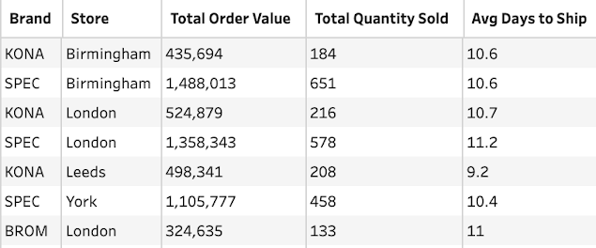](https://1.bp.blogspot.com/-vKiMGxugMJg/X_8FpFFpm5I/AAAAAAAACG0/BVU8dfchDR8z_3Oyfc8ruJ7j9S1OSVgqQCLcBGAsYHQ/s808/Screenshot%2B2021-01-13%2Bat%2B14.37.14.png)

5 Data Fields:

* Brand
* Store
* Total Quantity Sold
* Total Order Value
* Avg Days to Ship

25 Rows (26 including headers)